


WWC Cable Wakeboard World Championships
Hungary Budapest-Dunaharaszti 2005 Aug. 4.-7.

Bulletin 2
Version: May 2nd

List of contents:

1. Introductory 2
2. Place 2
3. Schedule 3
4. Accommodation 3
5. Transport, mini bus, rent a car 3
6. Alternative programs 4
7. Judge panel 4
8. Competition 5
9. Categories 5
10. Map of cableway and area 6
11. VISA 6
12. Training 6
13. Wakeskate 6
14. Home page 6

- Introductory

The 3rd Cable Wakeboard World Championships will be held in Hungary, Dunaharaszti. We would like to continue the tradition started with the first World Championships in Duisburg, 2001. So many international competitions (ECWT) were held at the cableway Dunaharaszti and one of the best European Championships was held here in 2002.
We expect this year’s World Championship to be as successful as the previous competitions here. We will entertain our guests with varied programs and high quality organization. We are expecting the record number of participants from all over the world and our aim is to organize a world event which is about the riders in the first place.
We would like to entertain the foreign visitors as well. Various alternative entertainments are waiting for those who will visit Hungary not only because of the World Championships. We try to allure more and more visitors with beautiful sightseeing tours and different facilities available at the competition area.

Hopefully the Cable Wakeboard World Championship 2005 will be unforgettable for everyone.

We are waiting for everybody with much love!

If you have any questions please don't hesitate to contact us,

Hungarian Wakeboard & Waterski Federation
Gyuri Kirsch – Chairman of Cable Wakeboard Council
federation@wakeboarder.hu

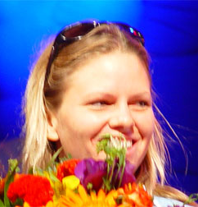
Dear all, I'm certain this World Champs will be a blast for both riders and visitors. And I do hope it'll be a blast for all indeed, men and women. When I started riding seven years ago I was well aware I'm about to enter the sport commonly considered as "masculine". Over the years I see more and more girls involved and I'm very happy about it. Still, when it comes to big events, national feds are inclined to support teams of best riders - mainly men. Why? Well, the number of women involved is still not high enough to have their categories open at national comps, even at the ECWT we never had Junior Ladies category. Consequently, there's practically no solid criteria to include them in national teams for the World Champs. However, it doesn't mean they don't know the sport, it's just that statistics still don't work in our favor…
My point is – actually, I have two points: 1. Girls, women, ladies, babes, chicks, pack your board bags, get over here and give the best you can to win a World title! 2. Feds, please support them, they're smaller and their performance is not as spectacular as men's, but if they try as much as I do, they try as hard as they can!

Hopefully the Cable Wakeboard World Championship 2005 will be unforgettable really for everyone.

Hungarian Wakeboard & Waterski Federation
Kinga Horvath – dedicated rider & secretary
federation@wakeboarder.hu

- Place

Universum Camping  Hungary 2330  Dunaharaszti  Alsó Némedi út | Tel.: 00-36-24-491-000  Fax: 00-36-24-490-807  www.vizisipalya.hu
- Schedule

2005. Aug. 4. Thursday 9-20h Official training

2005 Aug. 5 Friday 9-14h official training
14-19h Qualification Boys Girls Junior ladies
20h Opening ceremony

2005. Aug. 6. Saturday 9-19h Qualification Junior men Open men Open ladies Masters, Masters ladies, LCQ all categories

2005. Aug. 7. Sunday 9-13h Semifinal Open men, Junior men,
13-14h wakeskate demonstration
14-18h Final all categories
20h Price giving and party on the lake

- Accommodation

The Official WWC Cable Wakeboard World Championship Camping
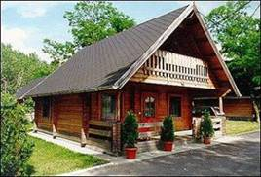
Universum Camping
Hungary 2330
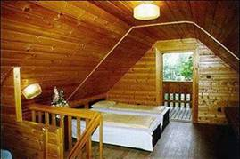
Dunaharaszti
Alsó Némedi út
Tel.: 00-36-24-491-000
Fax: 00-36-24-490-807
www.vizisipalya.hu

Prices:
House: 4 person / house : 65.- EUR
5 person / house : 74.- EUR
6 person / house : 83.- EUR
Tent: 2 person/night 8 euro / each + person is 3 euro /
Caravan: 2 person/night 16 euro / each + person is 3 euro /

The camping is situated next to the cableway.
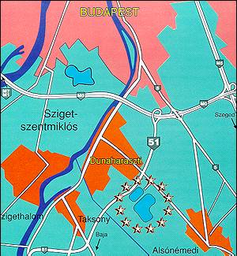
- Transport, mini bus, rent a car

A: Airport Budapest Ferihegy 2
Shuttle bus to Dunaharaszti
Taxi

B: Railway Budapest Déli station
Taxi

C: Road M1 Highway-M0 Highway- Exit Baja-Dunaharaszti 51
By the Coca Cola Company turn left and after 50 m turn right to the camping
Rent a car:

The following details are only informative. Please check the web sites for the prices.

www.rentauto.hu from19 euro/day
www.budget.hu from 49 euro/day
www.regina-rentacar.hu from 40 euro/day
www.europcar.hu
www.sixt.hu from 55 euro/day

- Alternative programs

Sightseeing:
Sight seeing 4 hour with courier max 16 persons 35000 HUF/group
Boat trip:
Boat trip on the Danube for 1 hour, and after that there is a 1 hour long trip to the Buda castle. 55000 HUF/group max 26 persons.
Trip to bend of Danube:
All day long program in Szentendre /XVIII. Century city/, Trip to Visegrad castle and Esztergom church.
64000 HUF/group max 26 persons

The above offers are just a few possibilities. We are able to serve groups from 4 untill 45 persons. You can have more information about the trips on the email address below.
peter@koltour.hu

We are waiting our guests on the World Championship with the following programs:
-Bungee Jumping 80m
-Film club with amateur wakeboard films
-World music cafe
-Concerts

- Judge panel

Chief Judge Tibor Althans GER?
Chief Judge Assistant Otto Némedi HUN

Judge Peter Wilkings AUS
Judge Chrystelle Wild FRA / GER
Judge Nicole Freeman GBR
Judge Lior Eliyahu ISR
Judge Giovanni Bellini ITA
Judge Zoran Bosak SVK
Judge Marcus Friedrich USA

Scorer

Chief scorer Stephan Freeman UK
Chief scorer Assistant Melinda Petrov HUN

Jetty Marshall Gabor Biró HUN

- Competition

It is in the responsibility of the National Federations to nominate their riders.
The number of participators per each age category or Open is not limited.
No minimum entry is required.

Entry fee: An entry fee of Euro 100,- per rider must be paid on arrival at the competition venue. This may be paid in Euro, or in other currencies at the exchange rate of the day.

Event rules: IWSF World Cable Wakeboard Commission 2005 rules apply. A full copy of the rules will be available on:
www.worldwakeboardcouncil.com

- Categories

Boys
Age 10 to 14 - If a rider was born in the following years, then they qualify for this category:
1990 and after

Girls
Age 10 to 14 - If a rider was born in the following years, then they qualify for this category:
1990 and after

Junior Men
Age 15 to 18 - If a rider was born in the following years, then they qualify for this category:
1989 - 1988 - 1987 - 1986

Junior Ladies
Age 15 to 18 - If a rider was born in the following years, then they qualify for this category:
1989 - 1988 - 1987 - 1986

Open Men
No age restriction

Open Ladies
No age restriction

Masters - Men
30 years old and over - If a rider was born in 1974 or before.

Masters - Ladies
30 years old and over - If a rider was born in 1974 or before.
- Map of cableway and area
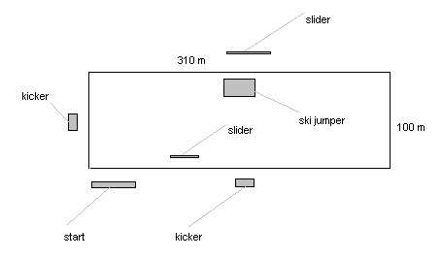
Drawing Facility:
Alta Cableway
(4 Mast system )

- VISA

You can find more information about Hungarian visa on web site below:

http://www.kulugyminiszterium.hu/archivum/Kulugyminiszterium/EN/StartPage.htm

- Training

You can buy training time for 100 euro/1 hour on Monday, Tuesday and Wednesday. /we have max. 4 hour/day/
You can buy hour ticket for 12 euro these days afternoon.
Official training is on Thursday and Friday morning for free.

- Wakeskate

The organizer would like to organize wakeskate competition with invitation before the finals on Sunday.

- Home page

For more information please visit the official Website of the 2005 WWC Cable Wakeboard World Championships

www.wakeboarder.hu

For any further information or inquiries please contact:

Contact person: Gyuri Kirsch
E-mail: federation@wakeboarder.hu
Phone: +36 70 380 3506 Fax: +36 1 250 6440
Address: Nándorfejérvári u. 8/c, Budapest 1117 Hungary

